**Microsoft Excel: Basics**

### **Microsoft Excel**

* Go to the Course Website
* Download and print “Business Analytics Week 1 Instructions.doc”
* Download “Business Analytics - Week 1 Excel.xlsx”

**Session 1.7: Calculations and Formulas**

* Highlight the four sales values for 2006. Notice at the bottom of the page, it calculates the average, count and sum of the values.

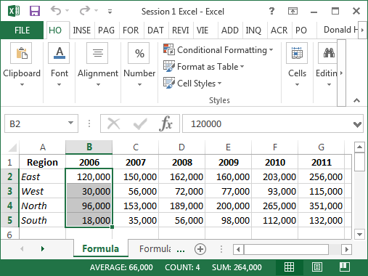

* Next, we’ll enter a formula in the spreadsheet to automatically calculate averages and sums
* In cell A9, type the word Average; also enter Average in I3
* In cell A10, type the word Sum; also enter Sum in J3
* To calculate a formula, use the equal sign, the name of the formula, and the data range
  + In cell B9, enter =average(b4:b7)
  + In cell B10, enter =sum(b4:b7)
  + In cell I4, enter =average(b4:g4)
  + In cell J4, enter =sum(b4:g4)
* Notice that after you type the equals sign and part of the formula name, it gives you several options that start with the same spelling; you can click on the one you want, then highlight the range of data

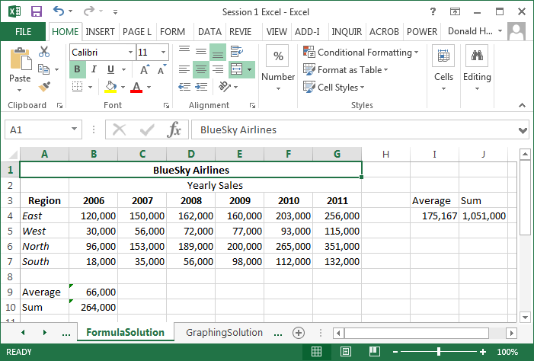

**Copy and Paste**

* Copy and paste works the same in Excel as in Microsoft Word, but you can also copy and paste formulas and Excel will automatically update formulas
* Copy the average and sum formulas across all columns and rows
  + Click on cell B9, click on the copy button in the Clipboard section (or use control-C), highlight cells C9 to G9, and click the paste button in Clipboard
  + Copy cell B10 across for the columns in the same way
  + You can copy several formulas at once. Highlight cells I4 and J4. Click on copy, then highlight the range I5 to J7, and click paste.
  + Look at the formulas in B9 and C9. How are they different?

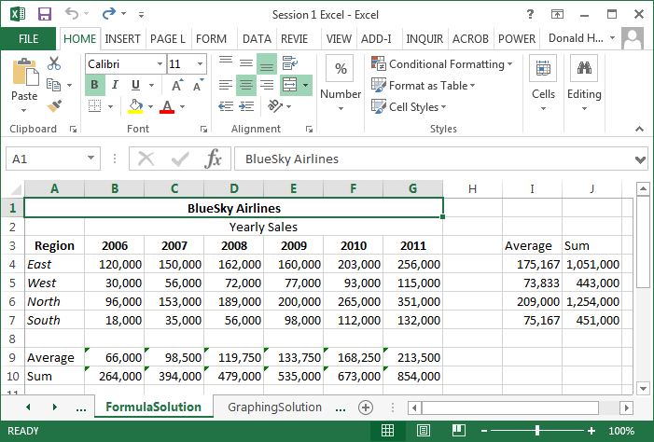

**Checking Formulas**

* Excel has an auditing feature to check formulas; click on the tab labeled Formulas
* Click on B9, then click on Trace Precedents in Formula Auditing
* To clear the arrows, click on Remove Arrows

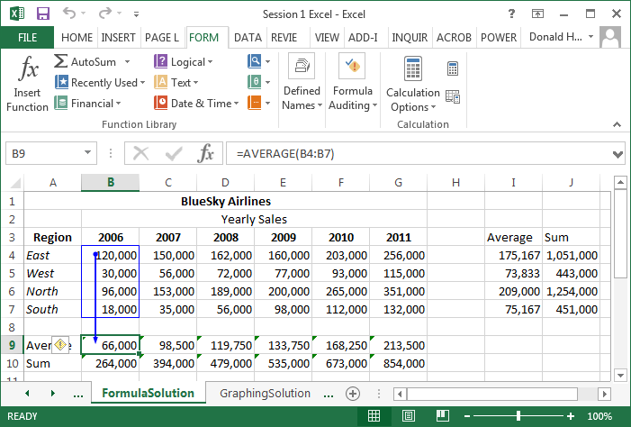

**Session 1.8: Graphing Data**

* Sometimes you might want to graph your data. Excel can graph columns and rows of data, but has difficulty if anything is in the upper left corner. First, delete the word Region by clicking on cell A3 and pressing the delete key.
* Highlight the data by clicking on the cell labeled A3 through G7.
* Next click on the Insert tab at the top of the screen.
* In the section labeled Charts, click on the tiny icon in the lower right corner of charts to bring up the possible chart options.
* Move the cursor over each options and select the 3-D column chart, click OK

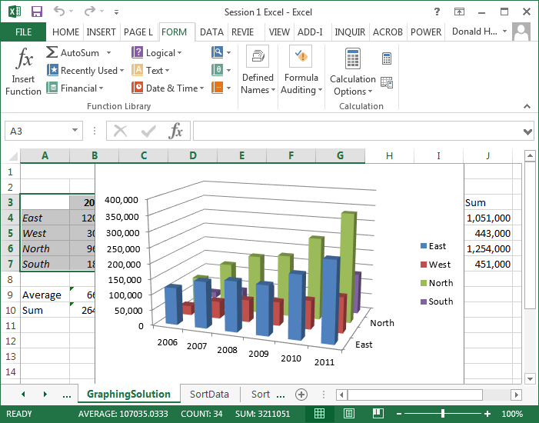

* Let’s move the chart to another sheet. Click on the upper right corner of Excel, select Move Chart Location, click on New Sheet, then OK.
* At the top of the screen click on Chart Tools: Design: Type, Change Chart Type to change the type of chart
* In the Chart Tools: Design: Data, click on Switch Row/Column. What happens?
* In the Chart Tools: Design: Chart Layouts, Quick Layout, there are several options (scroll down). How are they different?
* Next, try Chart Tools: Layout. Experiment with Labels and Axes. Under 3-D Rotation, change the X and Y rotation.

**Saving your Spreadsheet**

To save a spreadsheet, click on the Microsoft Office icon in the upper left corner of the screen, move the cursor over Save As. You’ll notice that you can save your Spreadsheet in a variety of formats.

**Microsoft Excel: Sorts, Filters, Pivot Tables**

**Session 1.9: Sorting Data**

* Use the SortData spreadsheet for this exercise.

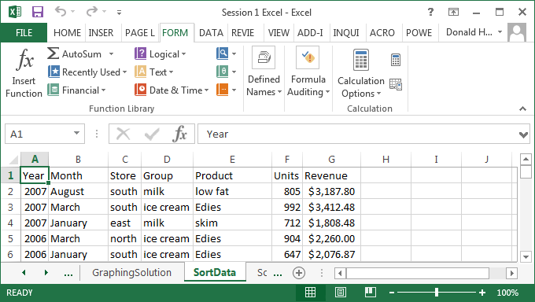

* To sort data, highlight the top of the columns (A through G). The entire columns should be highlighted.
* Click on the Data tab at the top of the spreadsheet.
* Click on Sort; note that “My data has headers” is checked. Why is it checked?
* Select the first sort criteria: Store
* Click on Add Level, then add the second sort criteria: Group

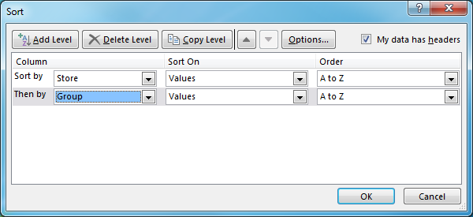

* Click OK, and the data is sorted
* How would you sort from Z to A (reverse alphabetical order)? Why would you want to sort in a different order?

**Filters**

* Use the FilterData spreadsheet for this exercise
* A filter allows you to select specific data out of a long list
* First, click on cell A1, then click on the Data tab, then Filter (looks like a funnel)

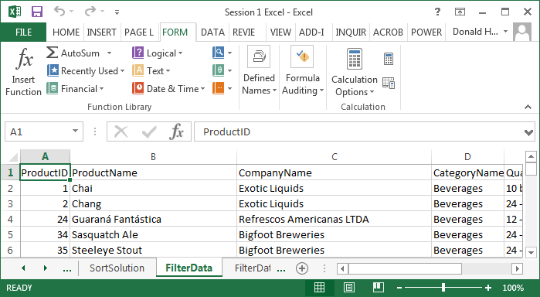

* Notice that there are drop down arrows for each column. Let’s find all products which Exotic Liquids produces.
* Click on the drop down arrow next to company name; uncheck “(Select All)”, then check Exotic Liquids and OK. What happens?

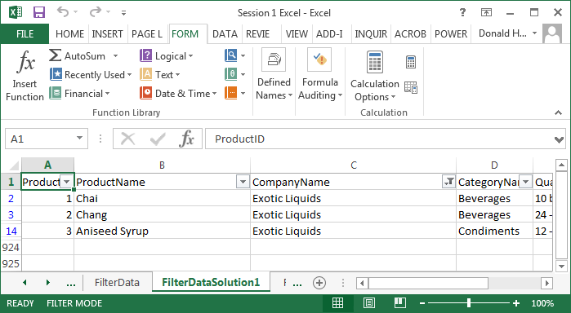

* Go back and click Select All for Company Name
* To find which products have a price greater than 50, click on the down arrow next to unit price, Number Filters, Greater Than, enter 50 in the field, and click OK
* You can turn on multiple filters. Add a filter for Category Name equal to Meat/Poultry to see which Meat/Poultry products cost more than 50

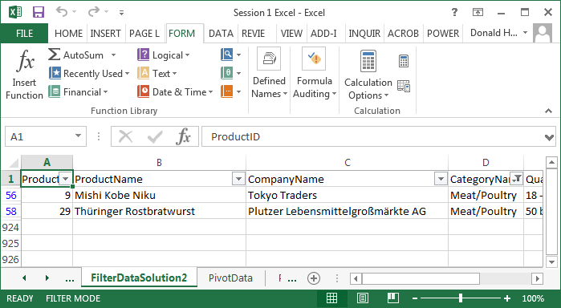

* To turn off the filter, click on the Filter icon and the drop down arrows should disappear.

**Session 1.10: Pivot Tables and Charts**

Pivot tables and charts are powerful techniques to quickly summarize and display large amounts of data. For this example, use the PivotData spreadsheet.

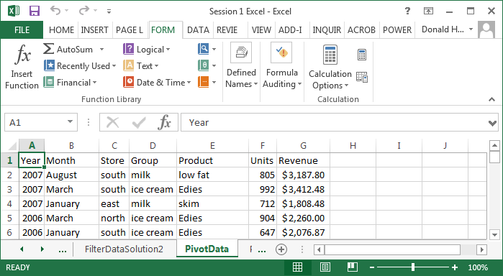

1. The headings must be in the first row of your data.
2. Click anywhere in the data table.
3. Click on the Insert tab.
4. Click on PivotTable; it should automatically highlight the entire table.
5. Make sure New Worksheet is checked, then click OK.

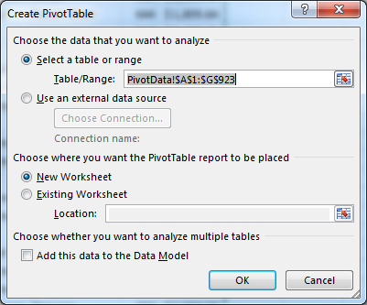

1. In the pivot table dialog box, we want to add row labels, column labels, and identify what goes into the table.
2. For this example, let’s build a table with store revenue by year. First click on store and drag it to the row label. These will become the row labels on the left side of your table.
3. Next, click on year and drag it to the column label. These will become the column labels at the top of your table.
4. Finally, click on revenue and drag it to the values cell. These values will feed the interior of the table. The default function is Sum. If you want to change this function, click on the down arrow in the values box, then select the function (average, min, max, etc.)

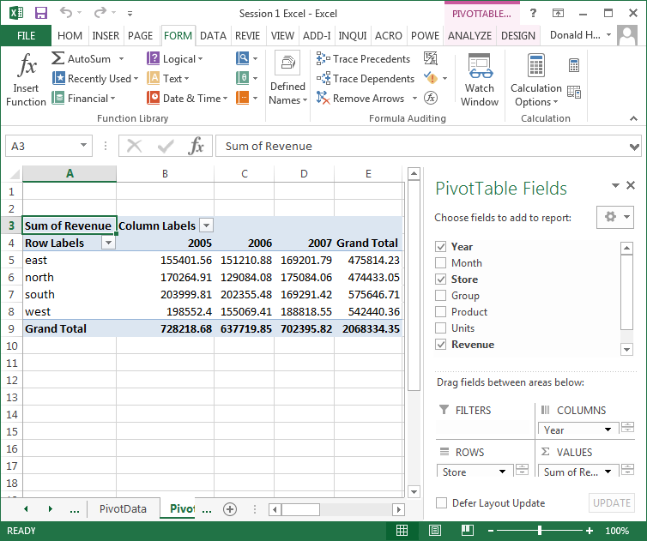

Add group to the row labels to see what happens.

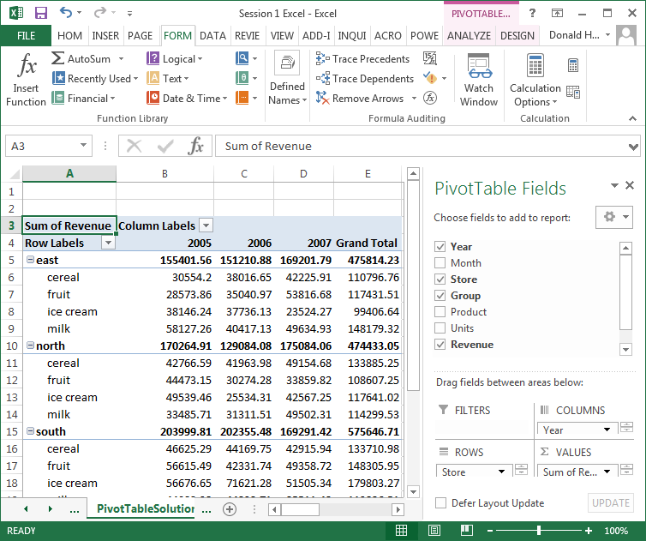

Let’s now create a Pivot Chart. The steps are:

1. Uncheck Group to simplify the data.
2. Click anywhere inside your Pivot Table. An Options tab will appear. Click on Pivot Chart.
3. A chart dialog box will appear. Click on your preferred type of chart.

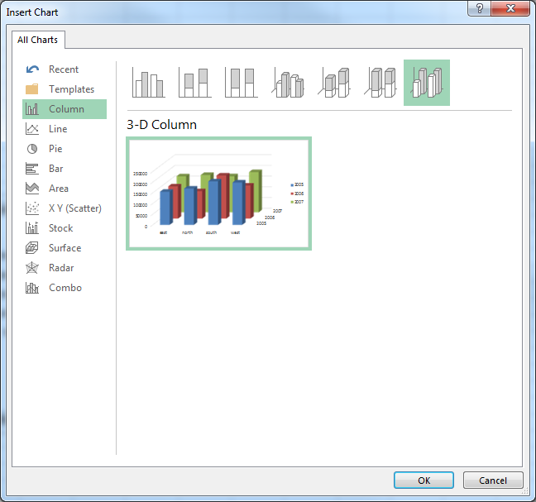

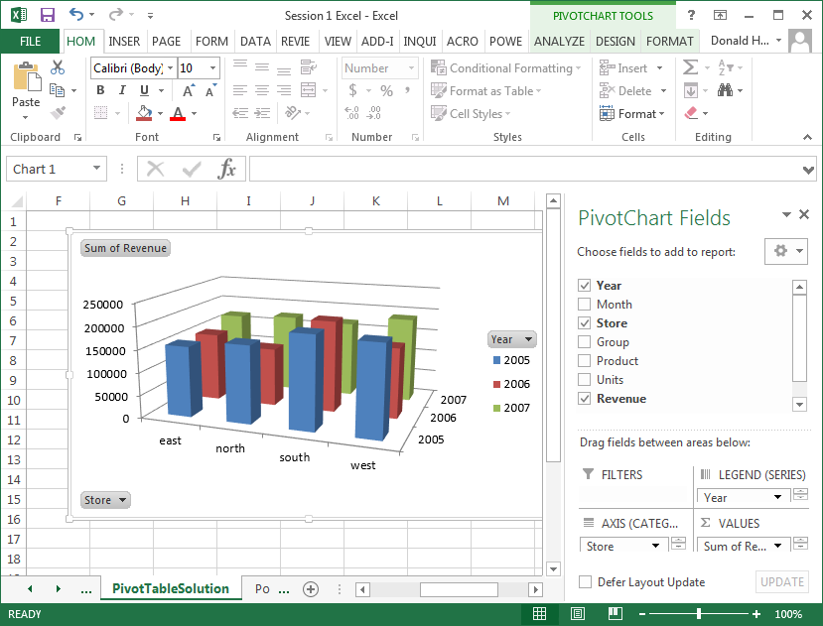

To move the chart to its own page:

1. Right click on the picture
2. Click on Move Chart
3. Select New Sheet and name the new sheet

**Microsoft Excel: PowerView**

**Session 1.11: Powerview**

**PowerView Add-in**

The PowerView options are available as an add-in to Excel. The steps to add it are:

1. In Excel, click on the File tab, then Options
2. Click on Add-Ins
3. In the Manage box at the bottom of the screen, select COM Add-ins, then Go
4. Check the box for PowerView, then OK

PowerView allows you to quickly generate business analytics graphs of complex data. PowerView is only available in Microsoft Excel 2013. Click on the PowerView spreadsheet for this exercise. This data is a list of international alumni from the Whitman School.

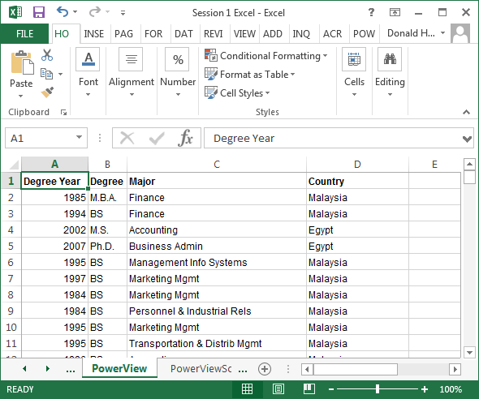

To generate a PowerView report:

1. Click on the Insert tab at the top of the screen
2. In the Reports section, click on Power View
3. In the Insert Power View screen, click OK.

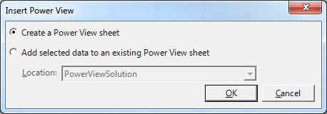

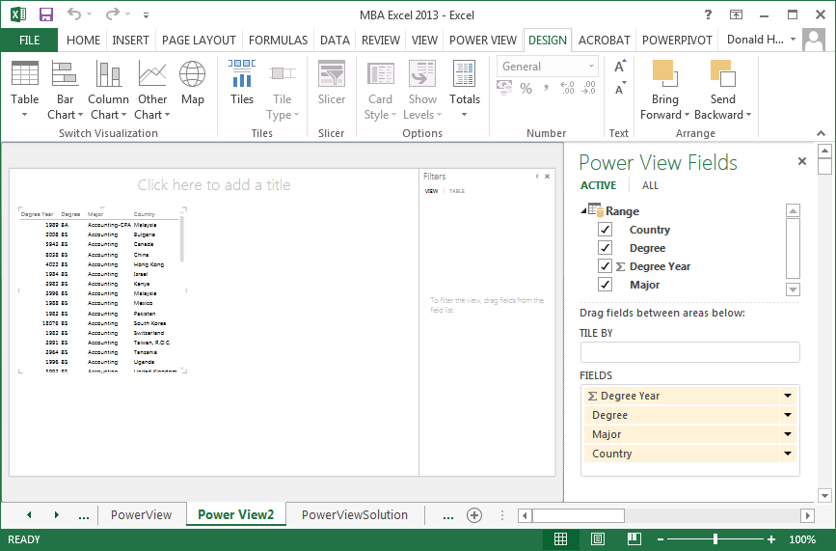

On the left side of the screen is your data. On the right side are the data fields or column labels (country, degree, degree year, major).

To create a map of degrees by country:

1. Uncheck Degree Year; uncheck Major
2. Click on the Map icon in the upper left portion of your screen

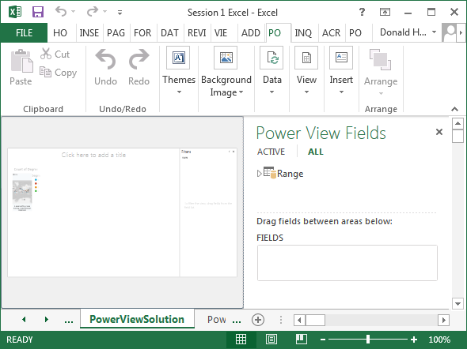

The map on the left is not very clear.

1. Move your cursor over the map.
2. An arrow in the upper right of the picture should appear.
3. Move the cursor over the arrow; it should say Pop out.
4. Click on the arrow.

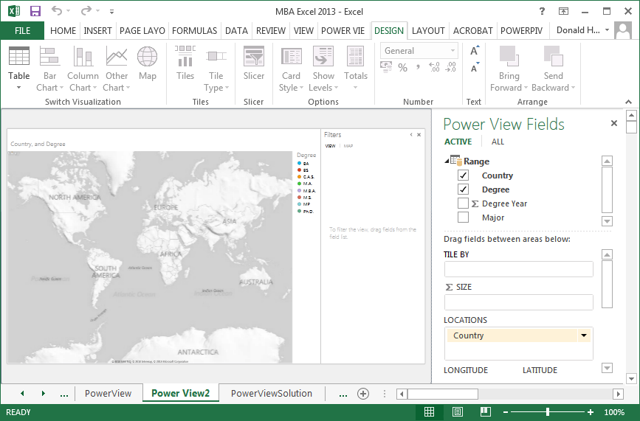

Now we have a picture, but no data. Notice that in the field labeled ∑ SIZE has no field entered. This field determines the data to be displayed. Drag Degree from Power View Fields to ∑ SIZE.

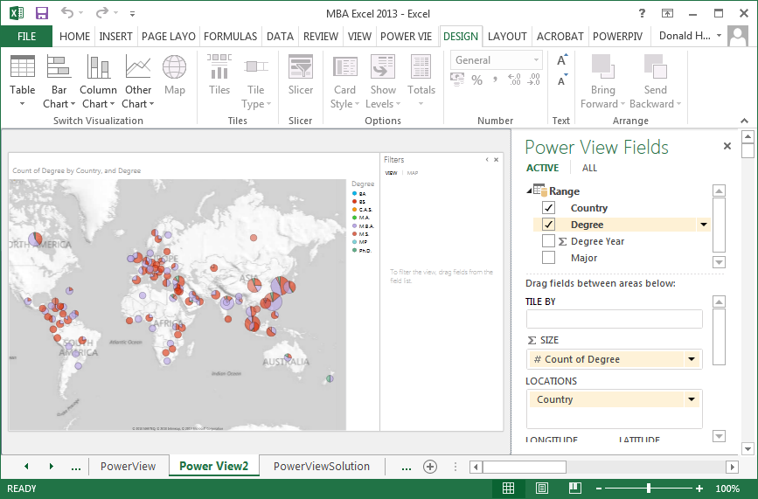

Be sure to have the following on the right side of the screen:

1. Drag Degree to ∑ SIZE; it should show # Count of Degree
2. LOCATIONS should have Country
3. COLOR should have Degree

Put your cursor over a country’s pie chart. By moving the cursor over different parts of the pie chart, it will give you the data associated with each pie segment.

You can also filter data to limit the data displayed on the screen. To activate a filter:

1. Click on the funnel to the upper right of the map.
2. In the Filters arrow to the right of the map, click on the arrow next to Degree
3. A list of degrees should appear. Check the degrees BS, MBA, MS and PhD
4. To reset to all degrees, click on All

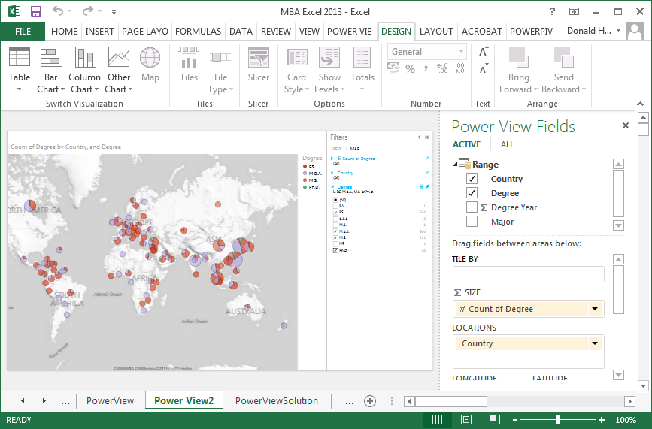

To add an additional layer of analysis, drag Major to Vertical Multiples.

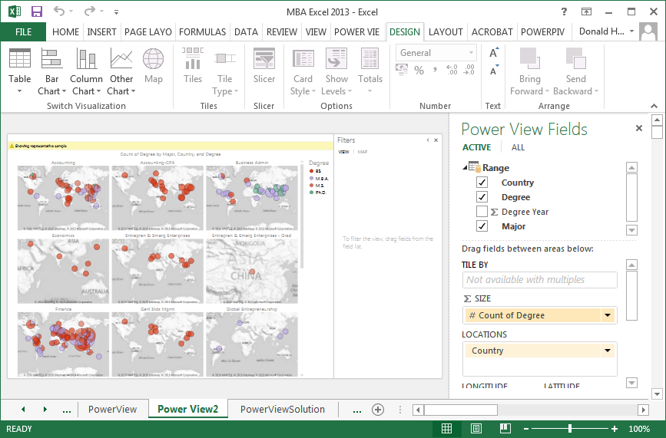

Drag it to Horizontal Multiples.

